**ONLINE CHAT-BOT BASED TICKETING SYSTEM**

**Overview of the Invention:**

**AI-Powered Chatbot- Our chatbot uses natural language processing (NLP) to understand visitor inquiries and provide relevant information. It can handle basic inquiries, ticket purchases, and provide tailored recommendations.**

**Integrated Ticketing System:**

**The chatbot seamlessly integrates with the museum's existing ticketing system, allowing visitors to purchase tickets directly through the chatbot.**

**Personalized Recommendations:**

**The chatbot can recommend exhibits based on visitor preferences, providing a customized experience.**

**Multi-Channel Availability**

**The chatbot will be accessible through various channels, including the museum's website, Mobile App, WhatsApp, Telegram, etc.**

**SYSTEM ARCHITECTURE:**

**Components of the System:**

1. Chatbot Interface: The chatbot serves as a virtual assistant, guiding users step by step through the ticket booking process. It starts by greeting the user and asking for basic details like their name, city, and other relevant information. In this case, the chatbot is interacting with a user named Nimit Dhingra, providing a personalized experience by addressing the user by name.

1. Greeting and User Interaction:
   * The chatbot greets the user with a welcome message, making the conversation more natural and engaging.
   * It then asks for the user's name to personalize the interaction, which enhances the overall user experience.
2. Processing User Requests:
   * The chatbot prompts the user to select their city (e.g., New Delhi) and the specific museum they would like to visit (e.g., National Museum).
   * It follows up with relevant questions based on the previous responses, making it easy for the user to navigate through the options without feeling overwhelmed by too many choices at once.
3. Handling User Input:
   * The chatbot is capable of handling various inputs via dropdown menus (e.g., for selecting the city, museum, nationality as Indian or Foreigner, and the number of tickets). These menus simplify the process for the user by offering pre-defined options rather than requiring manual input.
   * After selecting a museum, the user is prompted to specify whether they are an Indian or a foreign visitor, which could be relevant for pricing or ticket eligibility.
4. Understanding and Responding in Multiple Languages:
   * Although this specific image doesn't show language selection, a multilingual chatbot would offer users the option to communicate in their preferred language. The chatbot’s ability to process requests in multiple languages ensures accessibility for a wider audience, making it an inclusive solution for both locals and international tourists.
   * The chatbot’s natural language processing (NLP) capabilities enable it to understand user queries and respond appropriately in real-time, ensuring that users receive accurate and relevant information.

Processing Bookings:

After gathering the necessary information (city, museum, nationality, number of tickets), the chatbot processes the booking request:

* It verifies the availability of tickets for the selected museum and date.
* The system may offer additional steps, such as confirming payment or sending an e-ticket to the user.

Advantages of the Chatbot System:

* Automated and Efficient: The chatbot automates the booking process, eliminating the need for users to manually interact with a ticketing system or a human agent.
* Personalized: By addressing the user by name and offering relevant options based on previous inputs, the chatbot provides a personalized experience.
* User-Friendly: The dropdown options and structured questions make it easy for users to navigate the process, reducing confusion or errors.
* 24/7 Availability: Since the chatbot can operate without human intervention, users can book tickets at any time, improving convenience and satisfaction.

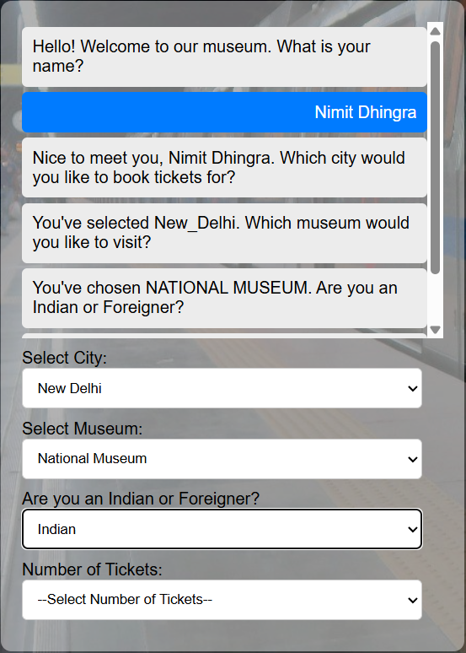

**Backend Processing Unit:**

In the ticket booking system using a chatbot, the **backend processing unit** plays a crucial role in managing user requests, retrieving data, checking ticket availability, and processing payments. Here's how the system functions step by step, leveraging **JavaScript** for processing, and **HTML/CSS** for user interface presentation:

**1. User Request Handling (JavaScript-Based)**

When a user interacts with the chatbot via the front-end interface (HTML/CSS), their input is sent to the backend for processing. The chatbot collects the user's queries (e.g., selected city, museum, nationality, number of tickets) and these requests are captured using **JavaScript**. The backend interprets these inputs to determine the next steps in the ticket booking process.

* **JavaScript’s Role**: JavaScript, as the primary processing language, manages real-time user inputs from the chat interface, validates data, and ensures that the communication between the user and backend systems is seamless. For example, it processes the dropdown selections (city, museum, nationality) and sends this information to the server for further action.

**2. Data Retrieval and Availability Check**

Once the user has provided their information, the backend processing unit retrieves relevant data from the database, such as available tickets for the selected museum, date, and user category (e.g., Indian or foreigner).

* **Database Queries**: JavaScript sends requests to the backend database to fetch data about:
  + Museum ticket availability
  + Pricing details for Indian and foreign visitors
  + Additional details like discounts, special promotions, or booking rules (if applicable)
* **Real-Time Ticket Availability**: After querying the database, the system checks the current availability of tickets for the chosen museum and date. If tickets are available, the chatbot informs the user and moves to the next stage (e.g., payment).

**3. Data Storage and Retrieval**

Throughout the process, the backend interacts with the database to store and retrieve information. The system uses database technologies like **MySQL**, **MongoDB**, or other SQL/NoSQL databases to manage ticket inventories, user profiles, and transaction records.

* **Ticket Data**: The system tracks available and sold tickets to ensure real-time updates in ticket availability.
* **User Data**: For returning users, the chatbot can retrieve stored data, such as past bookings, to provide a more personalized experience.

**4.JavaScript Workflow Example**

Here’s a simplified example of how JavaScript manages the backend processing:

* **Step 1**: User inputs (city, museum, nationality) are captured via HTML forms, and **JavaScript** sends these inputs to the server using **AJAX** or **Fetch API**.
* **Step 2**: The backend queries the database to check ticket availability.
* **Step 3**: JavaScript receives the response from the server. If tickets are available, it presents the payment options to the user.
* **Step 4**: Upon user confirmation, JavaScript sends the payment request to the payment gateway API.
* **Step 5**: After successful payment, JavaScript generates a booking confirmation and updates the backend database.

**6. HTML/CSS for Front-End Presentation**

While JavaScript handles backend processing, **HTML** and **CSS** are used to create a user-friendly interface that allows users to interact with the chatbot effectively.

* **HTML** structures the chatbot interface, presenting the input fields for selecting cities, museums, nationality, and the number of tickets.
* **CSS** styles the chatbot interface, making it visually appealing and responsive across devices.

The combination of HTML/CSS ensures that the chatbot is easy to navigate and provides a seamless experience to the user, while the JavaScript backend efficiently processes the information.

**7. Benefits of This Approach**

* **Real-Time Processing**: Users receive instant feedback on ticket availability and payment confirmations.
* **Scalable**: The backend, powered by JavaScript, can handle multiple user queries simultaneously, allowing it to scale for high traffic volumes.
* **Efficient Data Handling**: The system ensures that ticket availability is always up to date, preventing overbooking or errors in ticket issuance.
* **Secure Transactions**: By integrating secure payment gateways and using encryption, the system ensures that user transactions are safe.

In summary, the **backend processing unit** of this chatbot-based ticketing system leverages **JavaScript** for handling user requests, database interactions, and payment processing. Meanwhile, **HTML/CSS** ensures that the chatbot interface is presentable and user-friendly. The system efficiently checks ticket availability, processes payments, and ensures that users can book their tickets seamlessly.

**Multilingual Engine:**

The multilingual engine in the chatbot-based ticket booking system utilizes **Google Translator** to enhance its natural language processing (NLP) capabilities, allowing it to cater to a diverse global user base. It detects the language of user inputs in real-time and translates them into a language understood by the backend (usually English) for processing. Once the request is handled, the chatbot generates a response that is then translated back into the user's original language, ensuring seamless communication. This integration supports over 100 languages, providing instant feedback and responses that enhance user experience and accessibility, while also reflecting cultural sensitivity. However, it is essential to continuously monitor translation accuracy and gather user feedback to improve performance over time.

**Chatbot Functionality and Features:**

The chatbot designed for the ticket booking system operates as an interactive virtual assistant, guiding users through the entire booking process step-by-step. Here’s how it functions from the user's perspective:

**1. User Interaction: Step-by-Step Explanation**

* **Initiating the Chat**: When users first engage with the chatbot, they are greeted with a welcome message. The chatbot prompts the user to enter their name, personalizing the interaction.
* **City Selection**: After capturing the user's name, the chatbot asks which city they would like to book tickets for. Users can select from a predefined list of cities.
* **Location to Visit**: Once the city is chosen, the chatbot requests the specific museum or attraction they wish to visit, providing a list of options for easier navigation.
* **Time Slot Selection**: The chatbot then inquires about the preferred time slot for their visit, ensuring users can plan accordingly.
* **Nationality Inquiry**: Next, it asks whether the user is an Indian citizen or a foreigner. This information may affect ticket pricing and eligibility.
* **Number of Tickets**: The user is then prompted to specify the number of tickets needed, with a dropdown menu or input field for convenience.
* **Payment Summary**: After gathering all necessary information, the chatbot presents the total amount to be paid, summarizing the selections made by the user.
* **Payment Processing**: Once the payment amount is shown user makes the payment and a qr ticket is generated.
* **QR Ticket Generation**: Finally, the chatbot generates a QR ticket, which is sent to the user via email or displayed on the chat interface, serving as proof of purchase for entry.

**2. Multilingual Support**

1. **Language Detection**: The chatbot can detect the language of the user’s input in real-time using Google Translator. When a user starts typing, the system analyzes the text to determine the language being used.
2. **Dynamic Language Switching**: If the user switches languages during the conversation (e.g., from English to Spanish), the chatbot seamlessly adapts. It translates the user’s inputs and responds in the same language, ensuring smooth communication without requiring the user to manually select a language option.

**Consistent User Experience**: By supporting multiple languages, the chatbot provides an inclusive experience for users from various linguistic backgrounds, making it more accessible for international visitors.

1. Emergency Services Integration

Emergency services, the chatbot facilitates customer support inquiries, handling questions about bookings, refunds, or other concerns. It can provide instant responses or escalate complex issues to human agents when necessary.

In summary, the chatbot offers a streamlined, user-friendly ticket booking experience by guiding users through each step of the process, providing multilingual support for global accessibility, and ensuring real-time processing to maintain accurate booking data and prevent errors.

**SCALABLITY:**

To enhance scalability, we will develop a mobile application for both iOS and Android platforms, enabling users to conveniently book tickets on their devices. Additionally, ticket booking kiosks will be installed outside every tourist attraction, providing immediate access to ticket purchasing for visitors on-site. This dual approach not only streamlines the booking process but also accommodates a larger volume of users, ensuring a seamless experience whether they are booking in advance or at the location itself.

**Reference Images:**

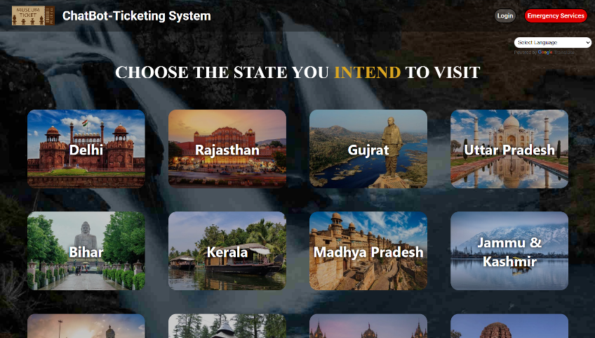

Home Page

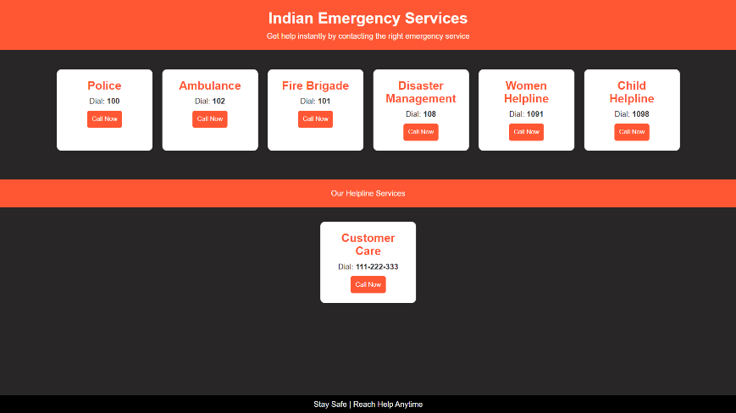

Emergency Services Page

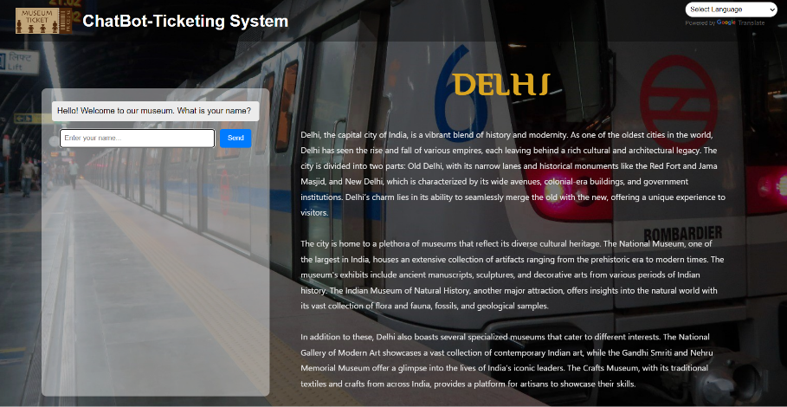

A State’s Ticket Booking Page

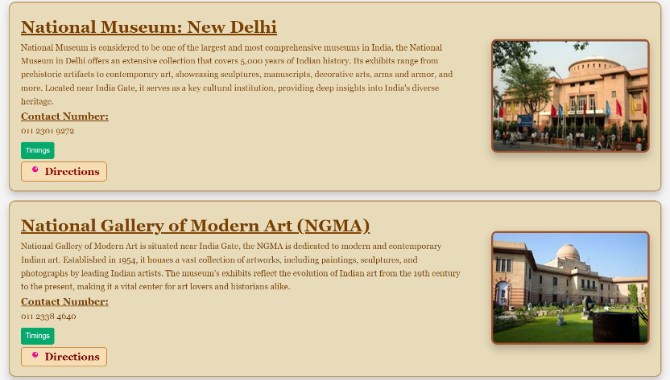

Information About Museum Of A State

**Work Flow Of ChatBot:**

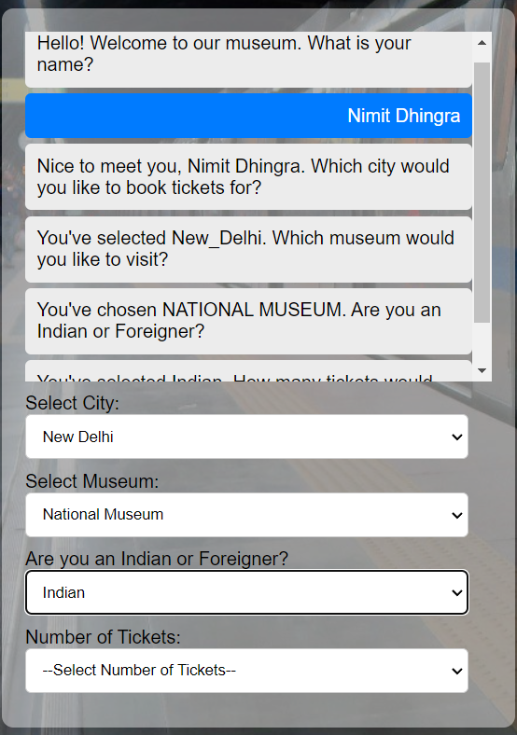

START

⬇️

Takes User Input

(name, nationality, no. of visitors,etc.)

⬇️

Generate a Ticket using the inputs.

⬇️

The User Prints their Ticket.

**The Generated Ticket:**

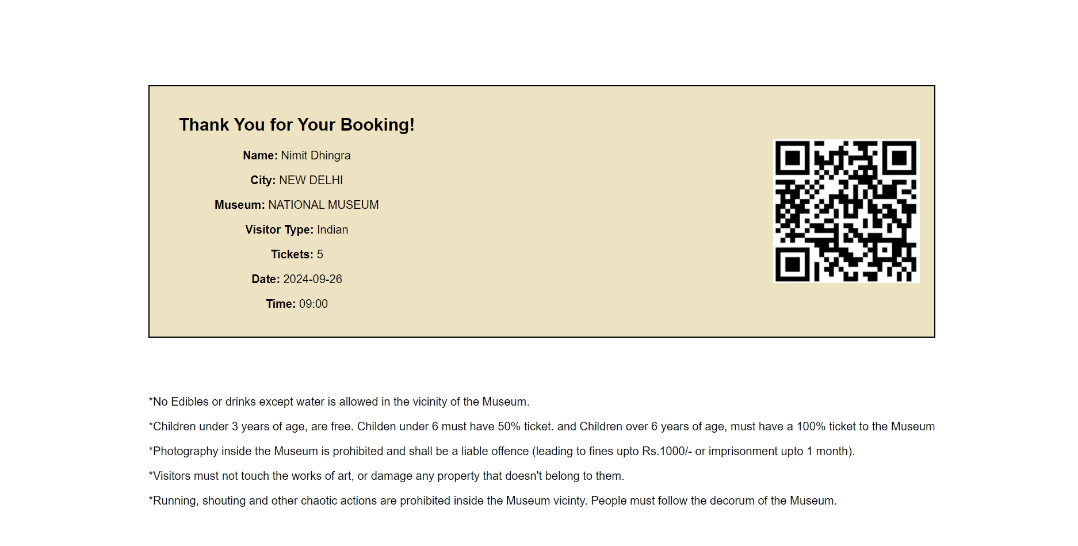

**Integration with Other Services:**

To enhance the user experience, the ticket booking system will integrate with various services, including car rentals, local guides, nearby food outlets, and accommodation options. This comprehensive integration will provide users with a one-stop solution for their travel needs, allowing them to easily arrange transportation, dining, and lodging alongside their museum or attraction visits. By offering these additional services, we aim to streamline the travel planning process and ensure that visitors have access to essential resources, enhancing their overall experience at tourist destinations.

✈️ 🚄 🚌 🚗 🍽️

**Advantages and Benefits of the Ticket Booking Project:**

1. Enhanced User Experience: The chatbot provides a user-friendly interface for ticket booking, making the process quick and intuitive. Real-time responses and personalized interactions enhance user satisfaction.
2. Multilingual Support: By offering support in multiple languages, the system caters to a diverse global audience, ensuring accessibility for international visitors and improving overall engagement.
3. Efficiency and Time Savings: Automated ticket booking through the chatbot reduces wait times and eliminates long queues at ticket counters, allowing visitors to plan their visits more efficiently.
4. Integration of Services: The inclusion of car rentals, local guides, nearby food outlets, and accommodation options provides a comprehensive travel solution, allowing users to arrange all aspects of their visit in one place.
5. Scalability: The development of a mobile app for iOS and Android, along with the installation of ticket kiosks at tourist locations, enables the system to handle increased user demand effectively, accommodating larger volumes of visitors.
6. Emergency Services Access: The chatbot facilitates quick access to emergency services, ensuring visitor safety and providing peace of mind during their travels.
7. Data Collection and Analytics: The system collects valuable user data, enabling museums and attractions to gain insights into visitor preferences and behaviors, which can inform marketing strategies and improve services.
8. Reduced Human Error: Automating the ticket booking process minimizes the chances of errors such as double bookings or incorrect ticket issuance, enhancing operational efficiency.
9. Cost-Effective Solution: The chatbot and integrated services reduce the need for extensive staff involvement in ticket sales and customer inquiries, lowering operational costs for museums and attractions.
10. Increased Revenue: By streamlining the booking process and providing additional services, the project can lead to higher ticket sales and increased revenue for attractions, contributing to their sustainability and growth.

In summary, this project offers numerous advantages that enhance user experience, operational efficiency, and overall satisfaction, while also supporting the business goals of museums and tourist attractions.

**Future Improvements:**

Discuss potential future upgrades or expansions for the system, such as:

* **AI-driven suggestions**: Recommending optimal travel routes or times based on user preferences.
* **Integration with additional services**: Expanding to include more travel, entertainment, or recreational services.
* **Enhanced security protocols**: Continuing to improve on security measures as technology advances.